D1_Nihar_84066

ASSIGNMENT 13

1. D1_nihar_84066>select Cname,City,'High Rating' Rating from CUSTOMERS where Rating>200 union select Cname,City, 'Low Rating' Rating from CUSTOMERS where Rating<200;

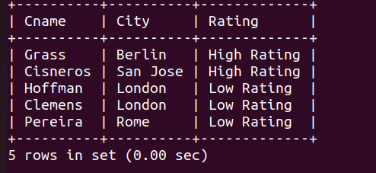

2. D1_nihar_84066>select SALESPEOPLE.Snum ,'Salesman' Sname , Sname from ORDERS,SALESPEOPLE where ORDERS.Snum = SALESPEOPLE.Snum group by SALESPEOPLE.Snum , Sname havin
g count(ORDERS.Snum)>1 UNION select CUSTOMERS.Cnum ,'Customers' Cname , Cname from ORDERS, CUSTOMERS where ORDERS.Cnum = CUSTOMERS.Cnum group by CUSTOMERS.Cnum, Cna
me having count(ORDERS.Cnum)>1;

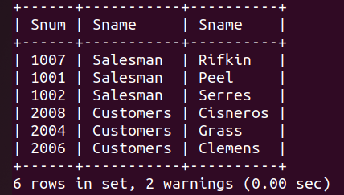

3. D1_nihar_84066>select Snum from SALESPEOPLE where City = 'San Jose' Union select Cnum from CUSTOMERS where City = 'San Jose' Union select Onum from ORDERS where Odate
like '%-%-03';

